Parts of an insect
Ladybird
Honeybee
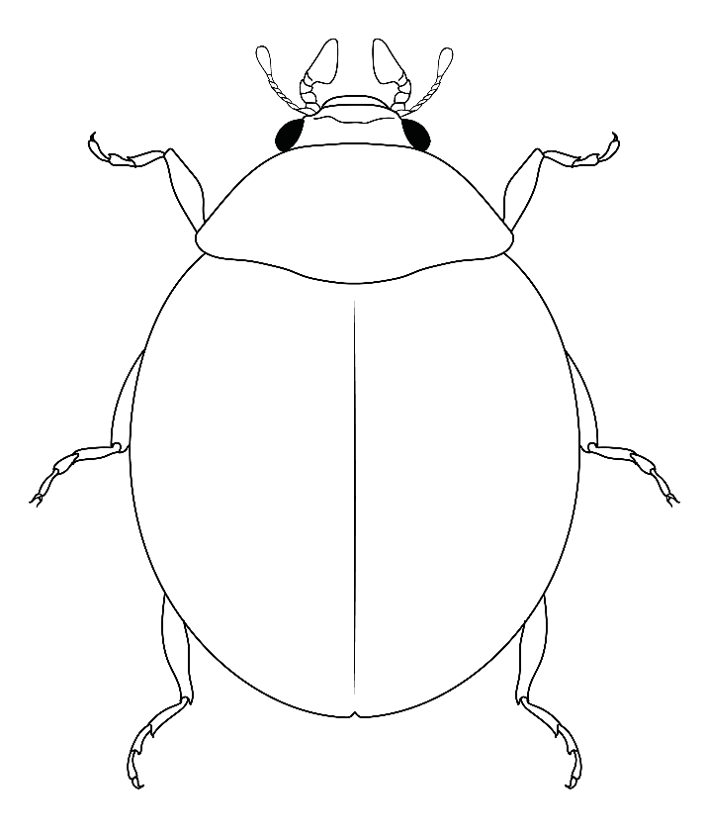
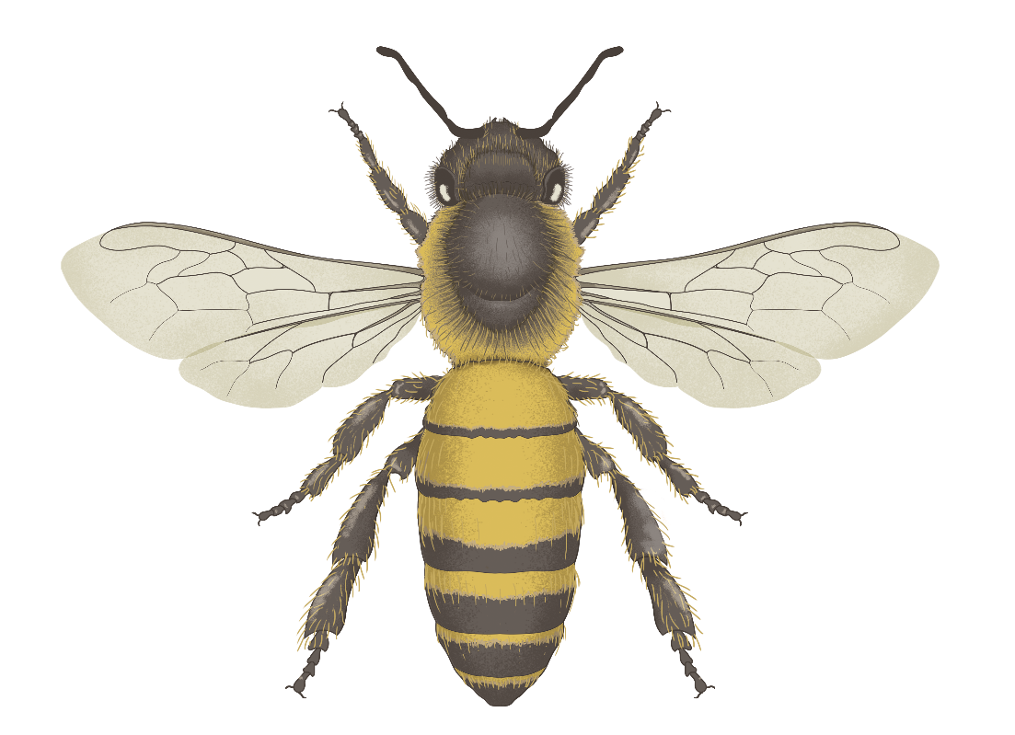
Word Bank
Head Abdomen Elytra Antenna
Thorax Wing Eye Leg

Maxillary palp
Parts of an insect (more vocabulary)
Ladybird
Word Bank
Head Abdomen Antenna Eye Elytra
Thorax Forewing Hindwing Leg Pronotum

Maxillary palp
Honeybee

*Feel free to swap in these other insects!
Ground beetle
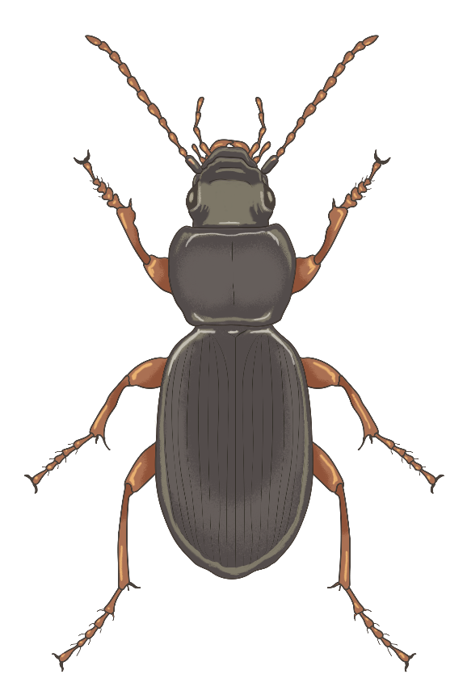
Hoverfly
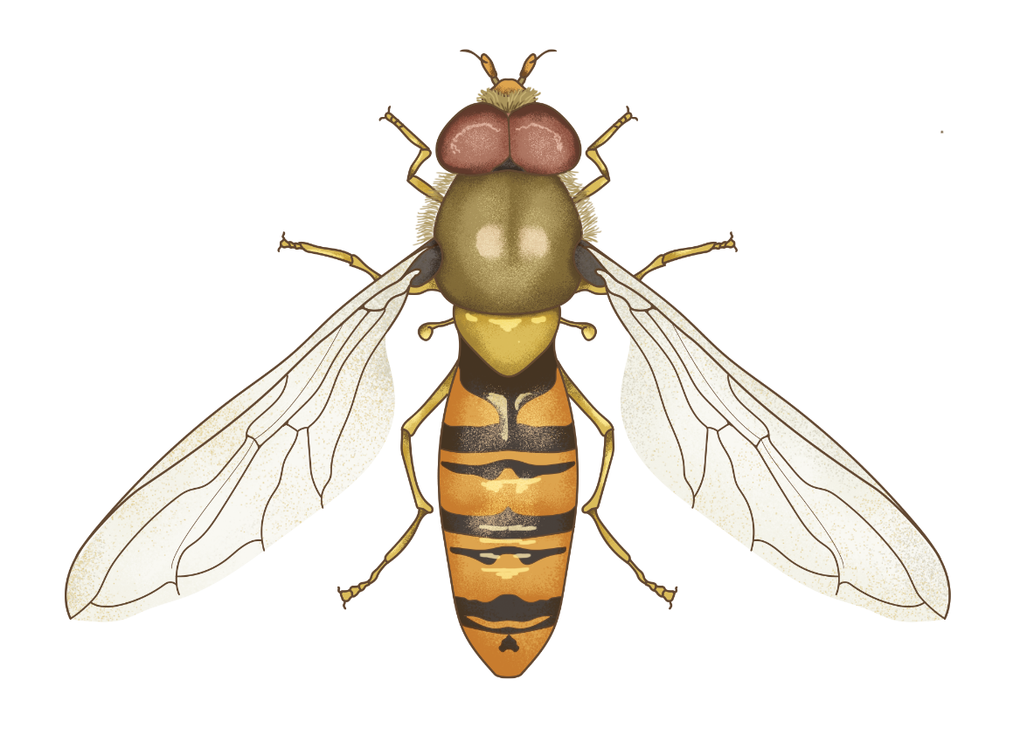

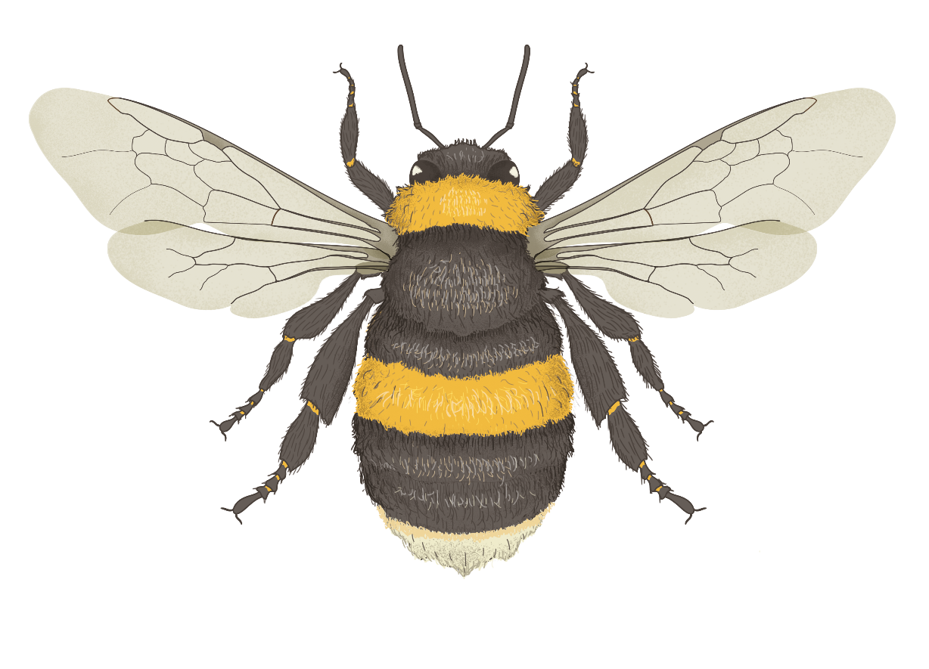
Bumblebee

